**Job Build manually, it completed successfully and mail sent:**

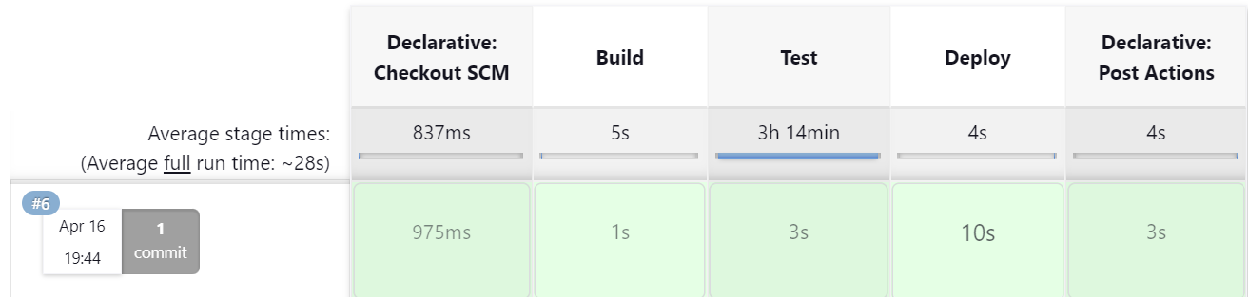

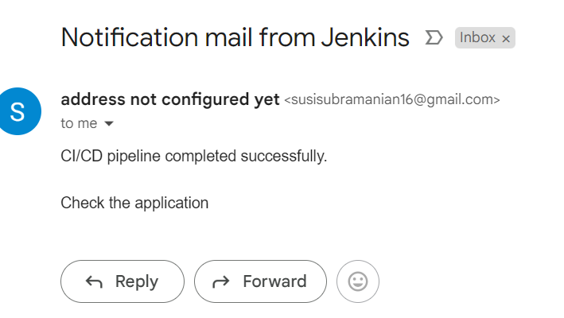

**Once changes is committed in github, jenkins automatically started to build using poll SCM configuration and mail sent:**

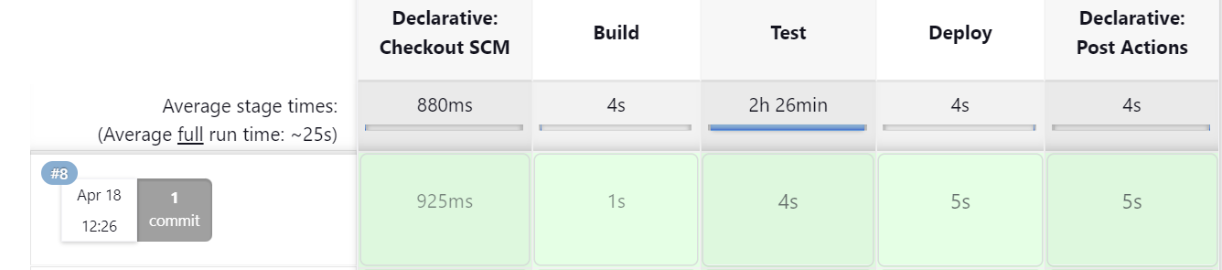

Highlights changes made in jenkinfile

